Operating System Navigation Checklist
Student Name: _____Jesus Torres_________________
Date: _______10/28/26_______________

Instructions
Navigate to each Windows feature listed below and take a screenshot showing the feature open.
Save all screenshots and upload them to your Week 3 GitHub folder.

Required Tasks
☐ Open Windows Settings
☐ Open File Explorer
☐ Open System Information
☐ Open Device Manager
☐ Open Task Manager

Screenshot Verification

Screenshot 1: Windows Settings
☐ Completed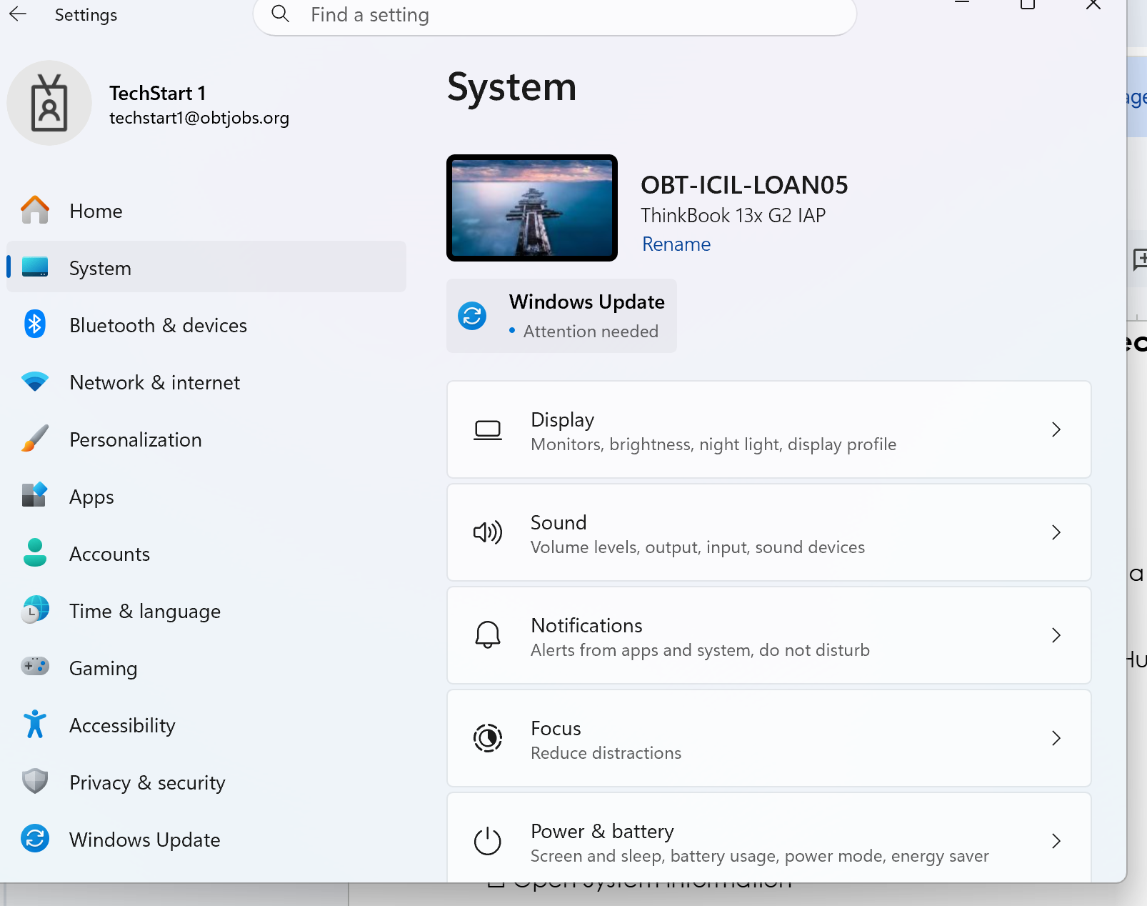
File Name: _________SystemSettings.exe _____________

Screenshot 2: File Explorer
☐ Completed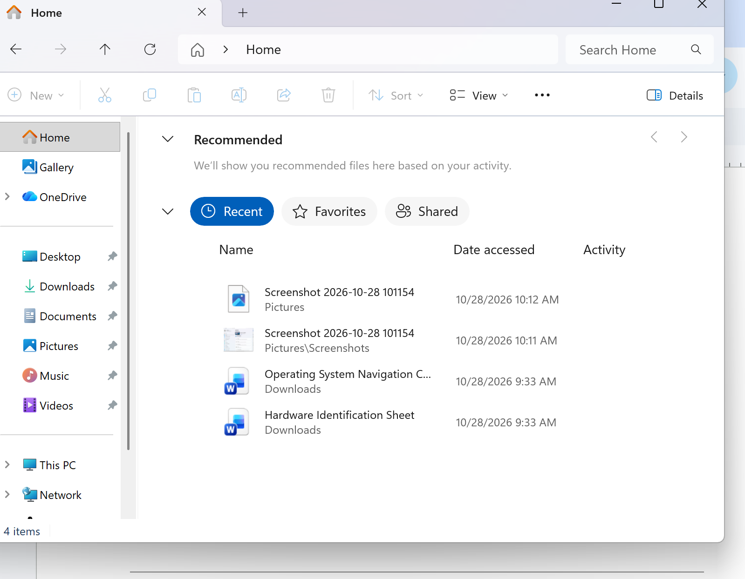
File Name: __________explorer.exe ____________

Screenshot 3: System Information
☐ Completed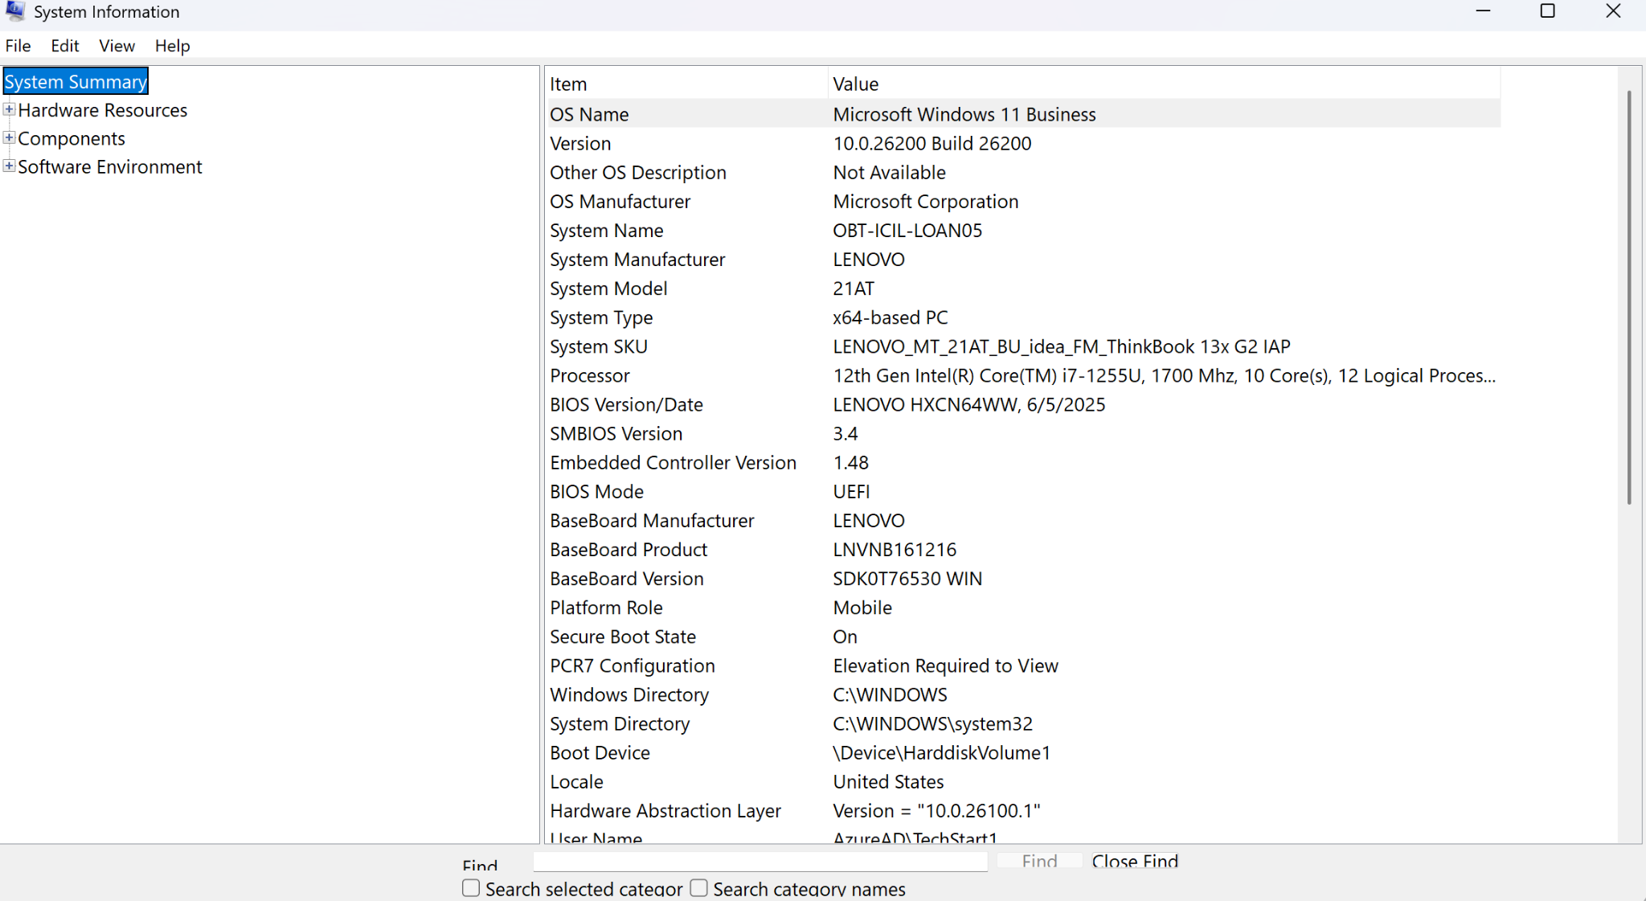
File Name: _________msinfo32.exe _____________

Screenshot 4: Device Manager
☐ Completed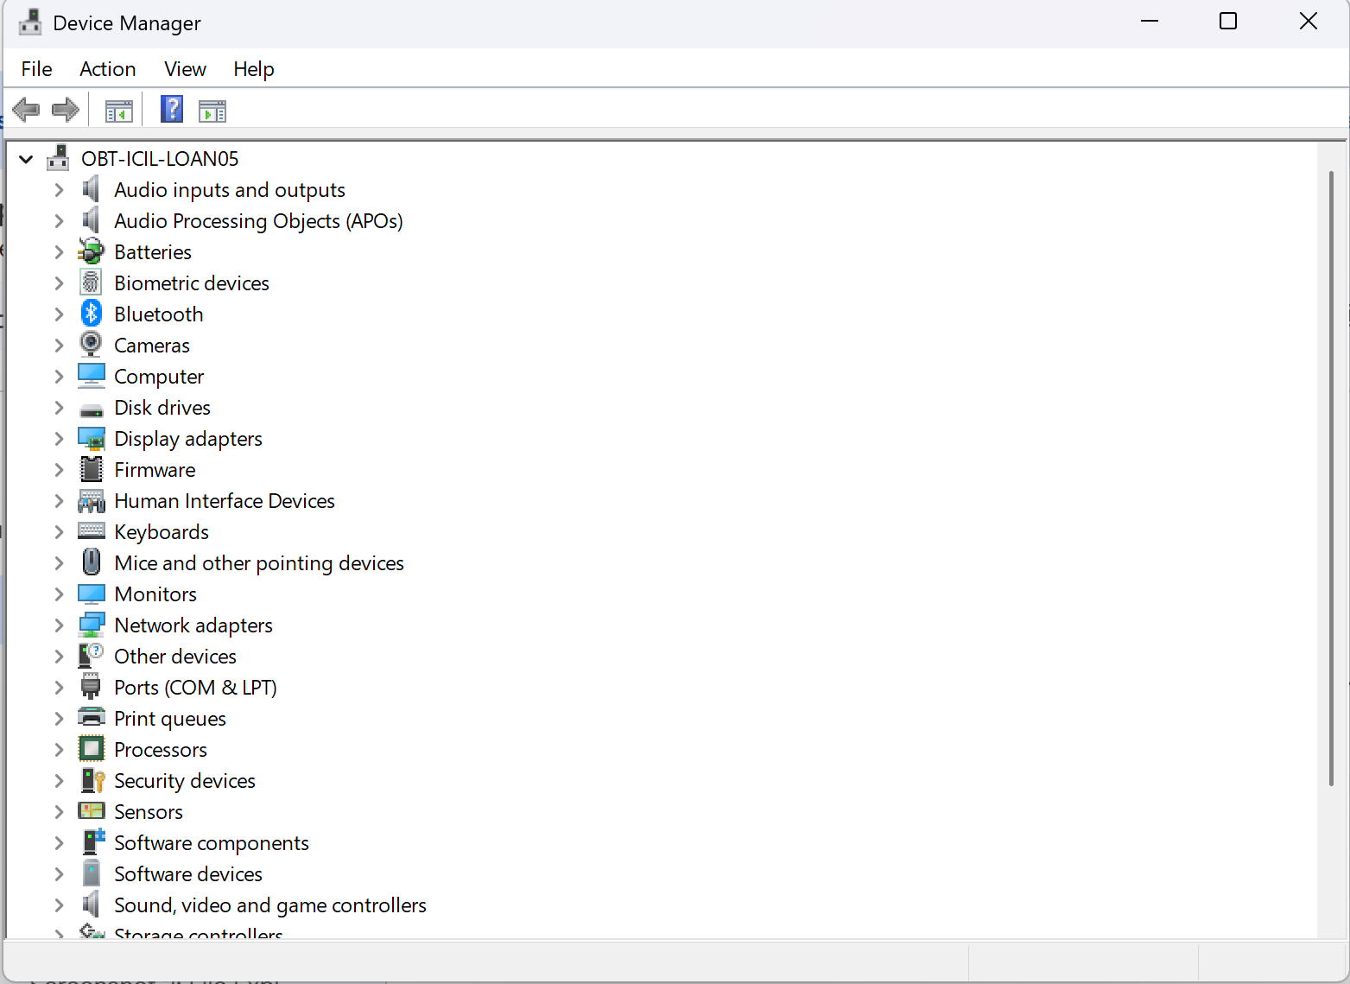
File Name: _________devmgmt.msc _____________

Screenshot 5: Task Manager
☐ Completed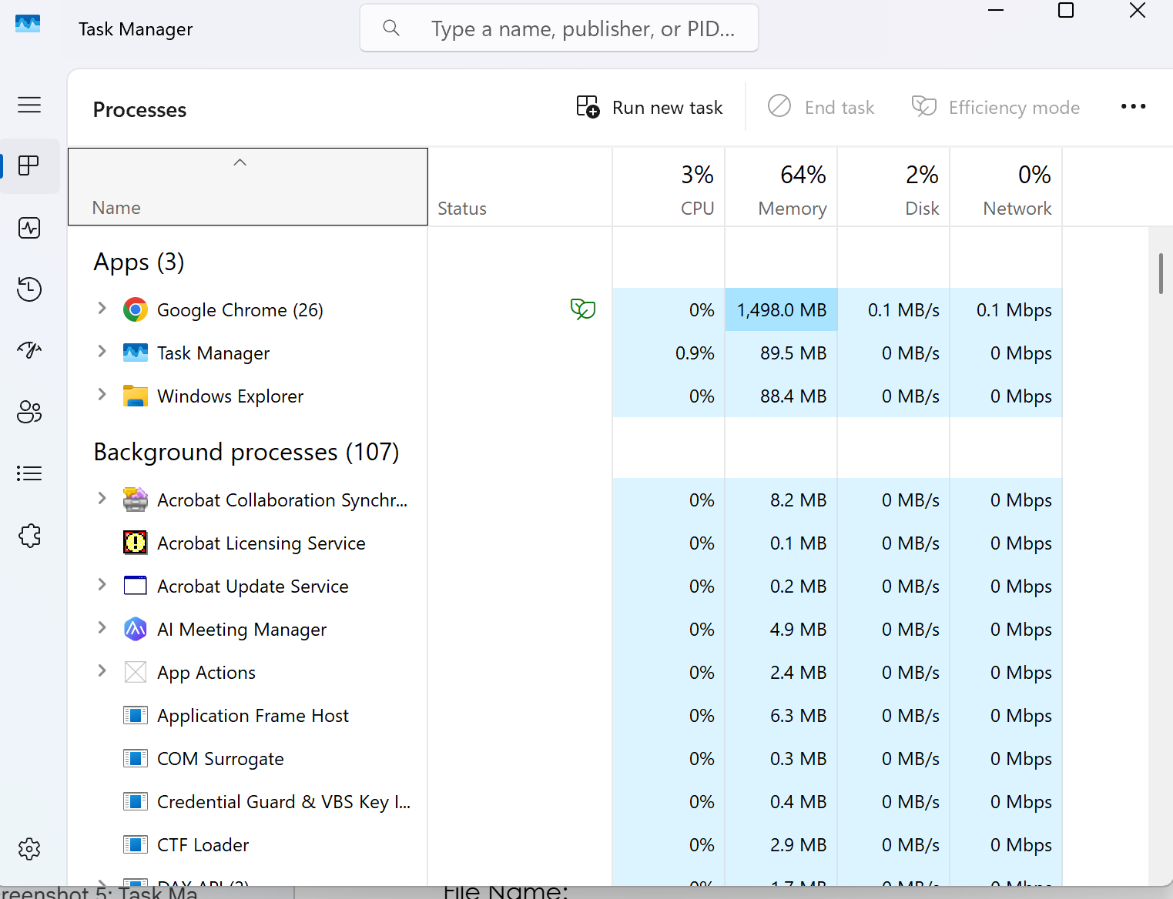
File Name: __________taskmgr.exe ____________

Reflection
Briefly describe what areas of Windows you accessed during this activity.
I was using the bluetooth and windows settings to get me there to connect my headphones as well change the system display to lower the brightness.

